

CS214: Design & Analysis of Algorithms SCIMS, FSTE

Final Examination Semester II, 2020

F2F/Blended Mode

Duration of Exam: 3 hours + 10 minutes

Reading Time: 10 minutes

Writing Time: 3 hours

Total Marks: 40

The exam covers the following learning outcomes:
CLO – 1: Evaluate the efficiency of algorithms (32.5%)
CLO – 2: Assess the suitability of different algorithms/data structures for solving a given problem (17.5%)
CLO – 3: Solve computationally difficult real world problems using appropriate algorithmic techniques (50%)

Instructions:

1. Write your answers in the space provided in this Question Paper.
2. Answer all questions. There are 10 questions and all questions are compulsory.
3. This exam is worth 40% of your overall mark. The minimum mark to pass the final exam is 16/40.
4. The total number of pages including this cover sheet is 15.
5. This is a closed book exam. No printed materials and electronic devices are allowed.

ID:___________________________ Name:_____________________________

SeatNo: _______________________ Campus: ___________________________

This page is intentionally left blank

Page 2
ID: _______________________

Using the appropriate data structure in a given algorithm is crucial for efficiency and performance. Different data structures offer various strengths and weaknesses, making them suitable for particular tasks while unsuitable for others. Choosing the right data structure can significantly impact the speed, memory usage, and overall complexity of an algorithm.
Examples:
- Arrays vs. Linked Lists:
  - Array: An array allows for quick access to elements via their index, making it excellent for scenarios where random access is needed. However, inserting or deleting elements can be costly, as it might require shifting multiple elements.
  - Linked List: A linked list is ideal for scenarios where frequent insertions and deletions are needed, as these operations can be performed in constant time. However, accessing elements is slower because it requires traversing the list from the beginning.
Is There a One-Size-Fits-All Data Structure?
There isn't a one-size-fits-all data structure because different applications have different requirements. Each data structure is designed to optimize certain operations at the expense of others. For instance, while arrays are great for random access, linked lists excel at insertions and deletions. Similarly, hash maps provide quick access but lack order, whereas tree maps maintain order but with slightly slower operations.

The Travelling Salesman Problem (TSP) asks for the shortest possible route that visits each city exactly once and returns to the starting city. The brute force approach involves evaluating all possible permutations of the cities and selecting the one with the minimum total distance.
Steps to Determine the Worst-Case Time Complexity:
- Number of Cities (n): Let’s say there are n cities in total. The problem requires visiting each city exactly once and returning to the starting city.
- Permutations of Cities: To find the optimal solution, the brute force approach evaluates every possible route (permutation) that visits each city once. The total number of possible routes (permutations of n cities) is given by:
(n−1)!=(n−1)×(n−2)×…×1(n - 1)! = (n-1) \times (n-2) \times \ldots \times 1(n−1)!=(n−1)×(n−2)×…×1
This is because, after starting from the first city (which is fixed), there are (n-1) cities left to visit. For each of the remaining cities, there are (n-2) choices for the second city, (n-3) for the third, and so on.
- Route Evaluation: For each permutation, we need to calculate the total distance of the route, which requires summing up the distances between consecutive cities. This requires O(n) time for each permutation.
- Total Time Complexity: Since there are (n - 1)! possible routes to evaluate and each route requires O(n) time to calculate its total distance, the total time complexity is:
O(n×(n−1)!)=O(n!)O(n \times (n - 1)!) = O(n!)O(n×(n−1)!)=O(n!)
The factorial growth is dominant, so the overall worst-case time complexity of the brute force approach for solving the Travelling Salesman Problem is: O(n!)O(n!)O(n!)
Conclusion:
The worst-case time complexity of the Travelling Salesman Problem using the brute force approach is O(n!), which grows extremely fast as the number of cities increases. This makes the brute force approach impractical for large n, as even for a relatively small number of cities, the time required becomes prohibitively large.

Page 3
ID: _______________________

int a = 0;
for (i = 0; i < N; i++) { for (j = N; j > i; j--) {
a = a + i + j; }
}

Same

same

Page 4
ID: _______________________

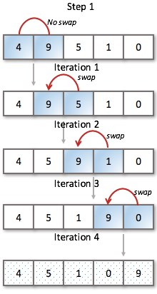
static void bubbleSortSimple (int S[]){

int n = S.length; int temp;

for (int j = 1; j < n; j++) {
for ( int i=0; i < n-1; i++ ) { if (S[i+1] < S[i]) {

temp = S[ i ];
S [ i ] = S [ i+1 ]; S [ i+1 ] = temp;
} }
}
}

…

(2 marks)

(answer both questions 5.1 and 5.2 here)

same

Page 5
ID: _______________________

int bin (int n, int k){ if (k == 0 || n==k)
return 1; else
return bin(n-1, k-1) + bin(n-1, k); }

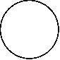
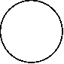
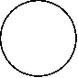
Hint: the worst case would be when k=n/2. You may start your analysis by completing the breakdown of the recursive equation as given below and identifying the pattern.

n k

n-1 k-1

+

n-1 k

... ... ... ...

This recursive function calculates the binomial coefficient using Pascal's identity:
C(n,k)=C(n−1,k−1)+C(n−1,k)C(n, k) = C(n-1, k-1) + C(n-1, k)C(n,k)=C(n−1,k−1)+C(n−1,k)
Identifying the Pattern
The number of recursive calls increases exponentially due to the recursive breakdown into two calls at each level. For every level in the tree, the size of n decreases by 1, and the recursion continues until the base case is reached.
The depth of the recursion tree is n because, at each step, n is reduced by 1. The number of nodes at any given level is equal to the sum of nodes from the previous level, making it resemble a binary tree with a height of n.
Worst-Case Scenario
The worst-case time complexity occurs when k = n / 2, which results in the deepest and widest recursive tree. At this point, the number of recursive calls will be maximal because the recursion goes down both subtrees symmetrically, yielding the most balanced tree.
Time Complexity Analysis
In the worst case, the total number of recursive calls is proportional to the number of nodes in the recursion tree. For each node, we are doing constant work, so the total number of nodes gives us the time complexity.
- At level 0 (the root), there is 1 call.
- At level 1, there are 2 calls (bin(n-1, k-1) and bin(n-1, k)).
- At level 2, there are 4 calls.
- In general, at level i, there are 2^i calls.
The total number of nodes in the tree (and thus, the total number of recursive calls) is the sum of all the calls at each level. This forms a geometric progression:
1+2+4+8+...+2n≈2n1 + 2 + 4 + 8 + ... + 2^{n} \approx 2^{n}1+2+4+8+...+2n≈2n
So, the worst-case time complexity is O(2^n).

Page 6
ID: _______________________
Are You Satisfied with O(2^n) Time Complexity?
No, O(2^n) is not a desirable time complexity, as it grows exponentially with n. This makes the recursive approach highly inefficient for large values of n and k, particularly in the worst-case scenario when k = n / 2.
How Can It Be Improved?
The solution can be improved using dynamic programming (DP) or memoization to avoid redundant calculations. In the recursive approach, many subproblems are solved multiple times, leading to significant redundancy.
Dynamic Programming Approach:
We can solve the binomial coefficient problem in O(n × k) time by filling in a DP table using the recurrence relation:
C(n,k)=C(n−1,k−1)+C(n−1,k)C(n, k) = C(n-1, k-1) + C(n-1, k)C(n,k)=C(n−1,k−1)+C(n−1,k)
We compute the binomial coefficients for all values of n and k from the bottom up, reusing previously computed results.
Time Complexity of DP Approach:
The DP approach has a time complexity of O(n × k), which is much more efficient than the exponential time complexity of the recursive solution.
Justification for DP Approach:
- No Redundant Computations: The DP solution ensures that each subproblem is computed only once, which eliminates redundancy.
- Better Time Complexity: O(n × k) is significantly better than O(2^n), especially for large values of n and k.
Conclusion:
The worst-case time complexity of the greedy recursive approach is O(2^n), which is not efficient. By using dynamic programming, the time complexity can be improved to O(n × k), making it much more suitable for larger values of n and k. Therefore, DP is a much better approach for solving the binomial coefficient problem efficiently.

Page 7

ID: _______________________

A music player is used to play one song at a time. Songs in the music player are linked to the previous and next song. you can play songs either from the starting or end of the list. A song can be either added or removed from the list. Choose the appropriate data structure that is most suited for this purpose and justify your choice? (2 marks)
For this scenario, a Doubly Linked List is the most appropriate data structure for a music player. Here’s why:
Justification:
- Bidirectional Navigation:
  - A doubly linked list allows traversal in both directions (forward and backward). This is ideal for a music player where you need to navigate to the previous or next song seamlessly.
- Efficient Insertions and Deletions:
  - Adding or removing songs from the list can be done efficiently with a doubly linked list, as it requires updating only a few pointers. This avoids the overhead associated with shifting elements in an array.
- Flexibility:
  - A doubly linked list provides flexibility in playing songs from the start or end of the list, making it easy to implement features like shuffle or repeat.
Conclusion:
Using a doubly linked list ensures that your music player operates efficiently, with quick access and modification capabilities, making for a smooth user experience.

Page 8
ID: _______________________

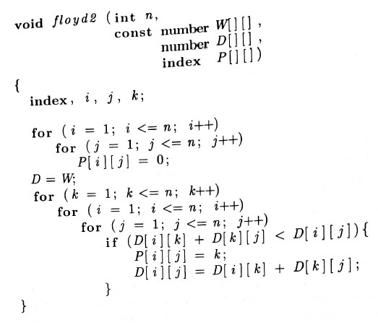
(a)

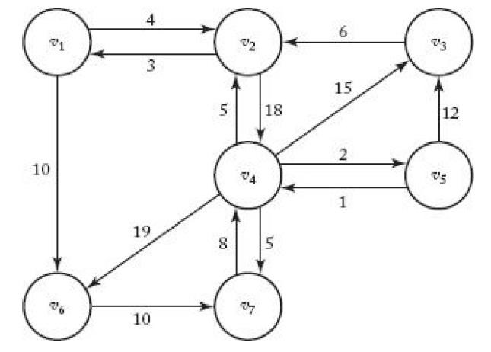
1 2 3 4 5 6 7 1 0 0 5 2 4 0 6 2 0 0 5 0 4 0 4 3 2 0 0 2 4 2 4 4 2 0 5 0 0 2 0 5 4 4 0 0 0 4 4 6 7 7 7 7 7 0 0 7 4 4 5 0 4 4 0

(b) (c)

Page 9
ID: _______________________

Page 10
ID: _______________________

Page 11
ID: _______________________

item 1 (2kg, $3) item 2 (5kg, $5) item 3 (3kg, $5) item 4 (8kg, $9) item 5 (1kg, $3)

The knapsack has a capacity of 8 kg.

Page 12
ID: _______________________

Page 13
ID: _______________________

Page 14
ID: _______________________

END

Page 15

